$1000 in a Week on eBay

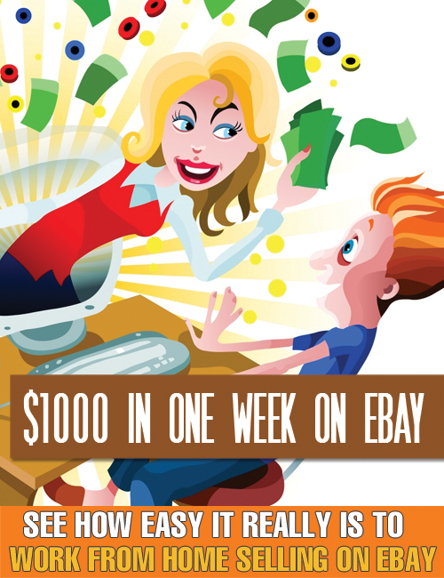

Brought to You by: You’re Site Here

LEGAL NOTICE

The Publisher has strived to be as accurate and complete as possible in the creation of this report, notwithstanding the fact that he does not warrant or represent at any time that the contents within are accurate due to the rapidly changing nature of the Internet.

The Publisher will not be responsible for any losses or damages of any kind incurred by the reader whether directly or indirectly arising from the use of the information found in this report.

This report is not intended for use as a source of legal, business, accounting or financial advice. All readers are advised to seek services of competent professionals in legal, business, accounting, and finance field.

No guarantees of income are made. Reader assumes responsibility for use of information contained herein. The author reserves the right to make changes without notice. The Publisher assumes no responsibility or liability whatsoever on the behalf of the reader of this report.

Table of Contents:

Chapter One: Getting Started
Chapter Two: Understanding Joint Ventures and eBay Sellers
Chapter Three: Setting up Joint Ventures
Chapter Four: The Joint Venture Process
Chapter Five: Getting Setup
Chapter Six: Proving the List in a Joint Venture
Chapter Seven: Setting up an Opt-in Website
Chapter Eight: Buying a List
Conclusion

Chapter One: Getting Started

One of the hardest things to get to grips with when you start out on your Internet marketing career is that money is quite easy to come by if you put your mind to it.

As workers we’re told from an early age that we must work for our money and that hard work equates to financial reward. Rubbish. Complete and utter rubbish.

How long would it take you to raise a thousand dollars now? I’ve mentioned in previous books how I’ve seen grown men in tears because they needed a little extra cash and couldn’t conceive how they would get it. To them an extra thousand dollars might as well be an extra ten million!

So would you have to work overtime for a month of two? Would you have to max out your credit card or go cap in hand to the bank?

Listen – a thousand Dollars in small change compared to the money you could make from Internet Marketing and Joint Ventures. I’m going to show you how you can bring in over a thousand Dollars time after time in around 2 days – maybe 2 weeks if you’re starting from absolute scratch and need a little preparation work.

Please let me explain…….

A little while ago I sent an email to an eBay seller. It was a very informal email. It started with the word ‘Hiya’

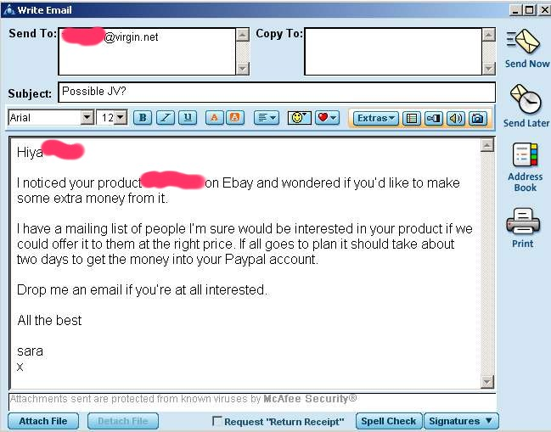

Not very professional I agree, but it was exactly what was required, because the following 48 hours resulted in me banking $2,500 (well it actually went into my Paypal account then my bank account a few days later). Unfortunately only half this money was mine, but still not bad for two days work.

The eBay seller was someone I’d never contacted before. A total stranger except for the fact that I knew of him because I’d spent some time browsing the listings.

Still I had no doubt that he would reply, even if it was a polite ‘no’.

In reality there was little chance of a ‘no’ really – would you say no to an email that suggested you could make a lump sum in two days from your own product? At the very least you’d want to hear more.

(Don’t worry this will all make sense soon.)

So my new EBay seller friend replied and we quickly sorted out a 50-50 split on a deal and I spent an hour or so writing another email. I also set a few other things up – a web site, Paypal button and a download page - took another couple of hours.

(I’ll give you the wording for the second email too.)

Now I wrote the second email out to a list of people I had recently amassed from eBay. I clicked the ‘send’ button then went upstairs to the kitchen (my home is over four floors). I poured myself a chilly glass of wine then came back down to my PC and opened my email software so I could watch the emails that I was now expecting to come in, in real-time.

Twenty minutes passed and I got a little worried – from past experience there was usually only ten minutes or so before I saw a result. I wandered away from the PC to feed the cats. It took about 5 minutes. When I got back to my PC I had a nice surprise.

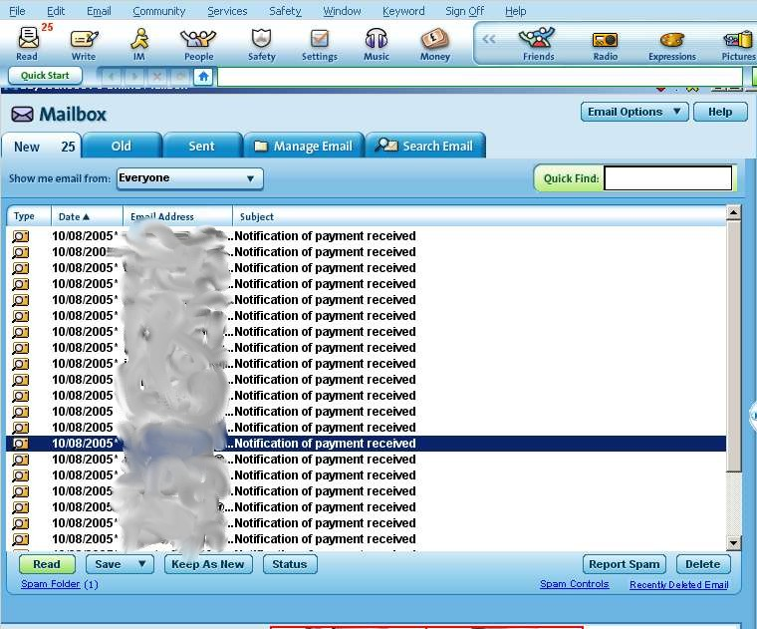

It’s a screen shot of the first 25 emails I received – they all came in within half an hour of me pressing my ‘send’ button.

I’ve smudged the email addresses of the people who sent payments for obvious reasons. The first 25 emails were from people who were actually sitting at their PC’s when my email arrived. Most people weren’t at their computers when my emails arrived. Those people checked their inboxes over the next day or so.

Over the next 48 hours the payment emails didn’t stop.

In total, when two days were up, I checked my Paypal account and found I had made just over £2,530. After deducting Paypal fees I sent half of this to my EBay seller friend who was incredibly happy to receive it (who wouldn’t be?) and took a couple of days off to go shopping.

And that’s it.

Chapter Two: Understanding Joint Ventures and eBay Sellers

WHAT’S IT?

You ask.

I’m going to show you how you can make a lot of money by undertaking JV’ (Joint Ventures) with eBay sellers.

You won’t need to have a product – just a list of people to email to offer the product to. Or if you do have a product, you can find a good seller to sell it for you.

Why should they buy it? Because it’ll be a quality product (you’ll have sourced it from eBay) and you’ll be offering it at a vastly discounted price that they cannot get anywhere else.

If you’ve ever seen this best selling ebook ‘EBay Auction Income Streams’ www.jobhaters.com advertised you’ll know it sells from most websites and on eBay for $24.99.

Now imagine if you really wanted the book and you received an email from a trustworthy eBayer you’d bought from before who offered you this best selling ebook for just $12.99 you’d jump at the chance and that’s how this system works. And boy does it work well!

This ebook is going to tell you how to set up your own JV (Joint Venture) with another person. Don’t worry there’s no need for telephone calls (unless you want to) it’s all done by email. It’s just a matter of identifying someone with a list of people to sell to, if you’re a product holder, or someone with a great product to sell, if you’re a list holder.

Then you just send them a simple email.

I was extremely nervous when I first approached a well-known marketer to ask if he’d like to undertake a JV with me. I was positive he’d either laugh at me or blast me for wasting his time.

But ask yourself if you got approached. How would you react? If someone told you could make a lot of money from your own product and all you had to do was agree to sell it below market price. You could then watch TV until your payment of maybe £3000 arrived.

How would you feel?

I would be both flattered and grateful.

Of all the JV’s I’ve undertaken – and they make up a substantial part of my yearly income – I’ve not once been turned down. Never.

And that’s not because of my business reputation. I’ve done JV’s under different names and through different email addresses when the need has arisen. All this is perfectly above board by the way, since it all goes into the same PayPal account for tax via different email addresses. I’ll tell you how to do that later, too. It helps you sort separate your JV money from any other sales you might have

It’s like doing a bungee jump. The first one is the hardest. Unlike a bungee jump you end up not with wet pants but with a few hundred quid at least in your pocket.

Chapter Three: Setting up Joint Ventures

Why would anyone want to do a JV with ME??

A Joint Venture (henceforth called a JV) is just a business undertaking – a deal where you split the takings. It usually (almost always) comes about when two people have skills or products that compliment each other.

You probably have more skills than you know but I’m not going to start telling you to reach down deep inside your soul to find your inner value when what you really want is a quick grand or so in the bank.

So for now we’ll concentrate on two things. Any one of these two items is enough for you to make hundreds if not thousands from a JV.

- A product you already own or have rights to
- A list of people who may want to buy a product.

Now I realise that not many people reading this will not have their own ebook, or software. BUT you may well have or be able to get hold of a product to which you have resale rights. If you can do that then a JV may well work for you as a product holder.

If you also have a list of people who have bought from you or even better, have a mailing list then you’re in the best possible position.

I’ll show you how to go about a JV from both angles.

I think the best approach to go is firstly to tell you how my latest JV worked.



My latest JV

Now I’ve done JV’s from both angles – as a person with a product and as a person with a list.

I’m lucky enough to have a product and a list but once I’ve sold my product to my own list it’s time to start looking around for other buyers – and this is where I need other sellers (usually eBay sellers). So I can sell to their lists too.

What do the other sellers get out of the deal? Fifty percent. Always.

I’ve heard of different splits but I think if you take on a partner you take on a partner and egos or tantrums don’t come into it. If I tried to demand 75% as a PowerSeller or Internet Marketer with a reputation I’d soon end up with no JV partners at all.

My advice would be to always treat your JV partner as an equal, even if you’ve far more experience. Even if you think your product is the greatest most in demand widget ever and you partner only has a list of 50 people. You still go 50-50 on the deal.

Happy JV partners come back to deal with you time and time again. If you’ve made them feel small or unimportant they won’t want to repeat the process even if they’ve made money from it.

Years ago when I was working in a poorly paid factory job and in a bad way financially I was forced to take on extra work. The new landlord of a local pub had just opened a children’s play area and wanted to promote the facility by getting a bouncy castle and face painters etc. for the afternoon. I agreed to work in a tiny burger van selling food to the families who attended. We worked out a price for an 8-hour day - $20 cash in hand.

I was broke so agreed to work for the twenty bucks. It was a hot August day and the heat in the tiny burger van was almost intolerable but it meant I could pay the gas bill so I stuck at it. Two hours before closing the landlord came to me and said he had to go out for the rest of the day so would play me now. He thrust a ten dollar bill into my hand. When I told him we’d agreed $20 he just told me he knew I needed the money so take it or leave it.

I felt humiliated and angry. He left and I spent the rest of the day giving away free food to the whole of the pub, especially the lads who turned up to watch the football. The landlord must have lost hundreds in missed takings.

I still bad-mouth the pub whenever I get the chance! He must have lost the ten Dollars he short-changed me with a thousand times over, and if I’ve anything to do with it, he’ll lose twice as much again!

The old saying that you should be nice to people on the way up because you’ll meet them again on the way down has a habit of becoming true.

So going back to my latest JV. I had no product to sell so I had a quick look around EBay.

I start by looking at PowerSellers who sell their own product. It’s no good me offering ‘David Blaine’s Magic Secrets’ because most people already own it, and those that don’t can buy it on eBay for under a Dollar.

So I need someone who either has control of, or has written their own ebook or software. By control of, I mean legal rights to resell the product. If you’re the one supplying the list don’t be afraid of asking for proof that they actually have the rights they claim, or you could both get into real trouble. Anyone legit won’t be offended. It shows your professionalism and protects both of you.

Back on eBay I settle down with a cup of coffee and start going through the listings in the categories that interest me.

Quick note: I deal in ebooks but you could just as easily do a JV with someone who has access to DVD’s, Playstation games, jewellery, books or kitchen appliances.

I actually found the seller whose product I thought best suited my list within 10 minutes, but I carried on looking and found two more eBay sellers who had suitable products. I didn’t contact them, but jotted their details down for future reference. They’ll make up part of my income for the future.
Just as I always keep an ’ideas’ book, I also keep hold of details of what else is selling oneBbay and who is selling it. Unless you’ve got a great memory, trust me, you’ll forget. It’s surprising when you’re trying to put a new venture or product together how much your ‘ideas’ and eBay products book can spur you on to fabulous a money making idea.

The product I found was similar enough to my own products to be of interest to my list but different enough so it wasn’t it direct competition with my own. I have sold totally different products that have worked incredibly well. You’ll get a ‘feel for what your list will go for after a while.

When you’re looking for a product it’s important that you offer it to your list at a significantly lower price than it sells for on eBay. OR choose a product that can’t be found anywhere else than directly from you. The latter only really applies if it’s your product.

The product I’d found for this particular JV sold for $25 on eBay. I estimated the seller was earning around S200 a week from his product. It was selling quite well but not enough for him to turn down any extra income.

I sent him an email.

Hiya ******

I noticed your product *********** on eBay and wondered if you’d like to make some extra money from it.

I have a mailing list of people I’m sure would be interested in your product if we could offer it to them at the right price. If all goes to plan it should take about two days to get the money into your Paypal account.

Drop me an email if you’re at all interested.

Your Name
x

The next day I received an email asking for more details. I offered a 50-50 split and we agreed that his product should be offered for $12.99 to one of my lists.

Very rarely you’ll try to deal with a JV partner who won’t offer his product at a lower price. All he can see is lost profit. In reality he’s actually gaining because he’s getting paid for sales he otherwise wouldn’t be making.

If he still refuses to drop the price, forget the JV. You must offer great deals to your list or they won’t stick with you.

So my new JV partner had the product, which he’d agreed to sell at half the price, and I had the list of potential buyers.

The list in question was one I’d populated by offering a free ebook. All they had to do to obtain was to agree to receive very occasional offers from me then enter their email address. In short it was an opt-in list. The names on the list had all opted to be contacted by me for at least one future offer. They could unsubscribe at any time. I’ll show you how to set up a page like this later.

I had used eBay as part of the publicity for my free ebook and got about 600 names in about two or three weeks. It sounds a lot, but when I tell you that some of the big boys in Internet marketing won’t send out an offer to a list with less than 10,000 names it puts it into perspective. Although with a list of this size they’re allowing for a poor sales rate. I’ve successfully mailed a list of just 100 people in the past; so don’t worry about size too much.

I think that if you offer a genuinely great offer at a price that can’t be found anywhere else then you’re looking at a 1 in 3 or even better sales rate. The ‘experts’ will disagree with me but the proof is in the pudding and I’ve had sales rates of 70% and above!

The JV in this example fits the above criteria so I think we’re onto a winner. I tell this to my new JV partner to reassure him about selling his product for less than he normally would.

Incidentally if you’re wondering why he agreed to sell his $25 product for half price then the answer is simply this. Firstly it’s an e-product so it costs him nothing to send out or copy. Secondly he’s not losing half his profit – he’s getting 50% of $12.99 for each sale that he wouldn’t have had if he hadn’t agreed to the JV with me. Thirdly I told him he’d probably make a couple of thousand quid in a matter of days.

(The split was 50% each after any PayPal fees had been taken out). So for each sale I get roughly $6 and my JV partner gets roughly $6. The rest goes on PayPal fees.

So what happens is once the JV is over I total up the takings, deduct any fees that are left and send him half. Most fees are deducted before the money hits my Paypal account but there are always the currency conversions plus any dodgy credit cards to be deducted.

If you’re the one providing the list to the JV, then YOU must be the one to email it. There are two reasons for this. If you just hand your list over to your JV partner to email, he is in effect spamming your list – they don’t have any relationship with him whereas they do with you. The other reason is that you would be handing over to him all your hard-earned email addresses, and he could use them himself. Remember ‘the gold is in the list’ and you could move on to a new JV partner, a new product and another thousand dollars or so the day after! Look after your list!

The email I send to my list read:

Hello,

I’m emailing you because you kindly opted-in to one of my mailing lists asking to receive details of any special offers I might have.

I am currently working with ********, producer of ********. This amazing product sells for $25 on eBay but I am able to offer it to you for just $12.99

If this offer is of interest to you, you can find out more details at www.*********.com

If you would like to unsubscribe from this list, just click on the link below.

Thanks.

The website is one I’ve specially set up from where my list can buy the product at $12.99. I put on a PayPal button that I’ll remove when the offer is over, and I’ll also shut down the site.

I could just as easily directed them to my JV partner’s own website where he could have changed the price from $25 to $12.99, but then he would have lost any $25 sales that would have come from his own marketing so he preferred me to do it.

So now we’ve come to the point where this ebook started.

I pressed ‘send’ and went to get some wine. Over the next two days we sold about 200 copies of his product bringing us a profit of over $2,500.

Once sales had tailed off I did as above. Shut down the site and sent him half the money. I also sent him a screenshot of my Paypal account showing the number of sales that had come in along with a record of the stats from a counter I’d put on the page. I didn’t have to because the whole thing has to be a trustworthy venture or it wouldn’t work, but I prefer to undertake my JV’s in this way. You’ll understand this if you’re the person being sent the lump sum after the JV.

So that’s it - $1200 for two days work. I didn’t sell a single product, and I have a happy JV partner who will be delighted to work with me again.

There are easier ways to do a JV than setting up websites though.

Chapter Four: The Joint Venture Process

Here’s an overview. I don’t like flowcharts but this one helps me when I’m putting together my own JV mailings:

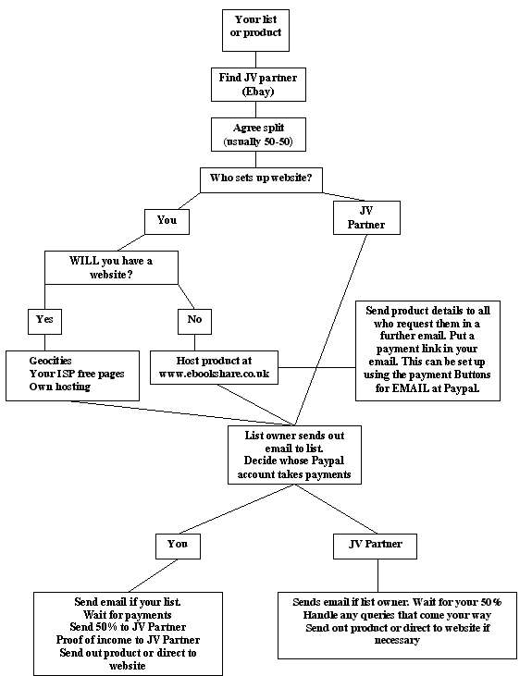

How to undertake a successful JV with little or no experience

First of all you need to decide which side of the JV you are on. Are you the person who will provide the product or the list?

Providing the product

Quickly recapping – if you have your own product (that you created or own sole rights to) or you have resell rights to a product that isn’t readily available elsewhere (if it is it won’t sell) then you can look at a JV from the point of view of the product provider.

Browse eBay and look for a seller. A PowerSeller will probably have a very good mailing list and be open to undertaking JV’s. Anyone who sells quite a few items per day or week is also a good bet. If you’re not sure, ask.

You will probably come across quite a few eBay sellers who don’t know what you’re talking about when you mention ‘Joint Ventures’. eBay has more than it’s fair share of people who sell from home and got lucky, but never look any further than eBay.

The notion of a JV to these people may seem odd. My advice would be to point them towards this ebook (sales for me!) or spend time explaining in more details what they’ll get out of it. Don’t focus too much on the actual JV, just on the fact that they could be $1000 richer by Monday morning.

When you’re looking for a seller, also bear in mind that a similar product to the one you’re selling would probably be a good idea as long as it’s not directly competing. Check his feedback rating too – it’s a reflection of how he runs his business.

I’m often asked when is the best time to send an email to your list. For along time I thought that early Saturday evening was the best time, and wouldn’t fluctuate from that time. The thinking behind it was that people have more time to read emails than on a weekday. The last JV I did went out on a Wednesday and the results were just as good. My opinion now is just to send the email out when it’s convenient for you.

When you’ve found a seller you like the look of (as far as you can tell from his Auction and About Me pages) you need to make the initial approach.

All it takes is a simple email.

Hiya,

As a reputable eBay seller I wondered if you’d like to join me in a venture that should bring you a lump sum in about 2 days. I’m about to launch a product and wondered if you’d like to offer it to your list on a 50-50 basis?

If you’re interested drop me an email and we’ll go through the detail.

Thanks

It’s best not to try to sell the whole project in a first email. If they’re interested – and they usually are – they’ll get back to you and you can send a follow up email about price and the logistics of the venture.

Chapter Five: Getting Setup

You will obviously need a PayPal account but these are easily set up. If you use eBay you’ll probably have one already.

The best way to sell your product is to set up a temporary website (with a PayPal button) that you can direct your customers to. Geocities is an option for this. You can use the website to take payments for two days then take it off the net.

Instructions for doing the above can be found at www.geocities.com (you’ll have to sign up for a free Yahoo account first) and www.paypal.com (go to Merchant Tools on the top menu then the website buttons tutorial) both are free.

Once this is set up you can draft an email to your customers (like the one mentioned earlier) directing them to the website. Your JV partner then sends the email that you composed out to his list (as though it came from him), and you wait for payments. You must agree before the venture starts who sets up the website and delivers the product, and who sends the emails. The person who owns the list must send the emails. This is because of spam issues mentioned earlier. Otherwise he would have to send his list to his partner, and that could lead to list theft.

It’s not until you’ve actually undertaken a JV that you’ll realize how incredibly powerful and lucrative these deals are. I can think of no better way to bring in a nice cash boost in a very short amount of time.

Now there has to be an amount of trust in these ventures. There’s no getting around the fact that one of you has to take the payments. There might be a way of splitting each Payment 50-50 as it comes in – probably using Clickbank (www.clickbank.com) or some other payment service. If anyone knows how to do this on Paypal please let me know!

In any case this will probably cost and the whole point about JV’s in my view is that they’re easy to set up and can be over and done with in a couple of days, cash in your bank and a smile on your face!

I will say that I’ve never had a problem with a JV either when I’ve been the one taking the money or my JV partner has been the one taking the money. Just split everything 50-50 at the end of the venture and there’ll be no problem. Success is based on honesty (unless you’re a politician).

I take a screenshot of my PayPal account (download ScreenPrint32 from www.download.com - it’s a great free utility) and send it to my JV partner as proof of earnings.

Earnings from each individual JV you undertake can be easily separated from each other by firstly adding an email address to your PayPal account (PayPal main screen – Profile – Account information – Email – Add) then accepting payments to this email address only from the PayPal button you use in your JV. Once the JV is over you can see all the payments that have been received to that email address by going to (PayPal main screen – History – Payments received to – your new email address)

It’s not necessary but it’s a nice touch. I also set up a counter on my website to show how many people have accessed the download page. This isn’t totally accurate as many people download more than once if the download is interrupted or occasionally pass on the download link to a friend to get the product without paying. This is rare though and a counter does give a reasonable idea of how much money has been taken.

You can set up a free counter by going to www.statcounter.com

It’s invisible to your customers and you can share login details to the statcounter website with your JV partner so he can see for himself how many download page accesses there have been. That way he’ll have a rough idea of how much money to expect.

Once the payments have come in, total it up, deduct any fees then send your JV partner half. If you’re declaring your income to the tax people then get a receipt from your JV partner for the money you send. Otherwise when you do your yearly accounts it’ll look like you earned £2,500 in two days rather than half that amount and you’ll have to pay tax on it.

If you don’t want to set up a website to sell the product you can ask (in your first email) your list to email you for further details of your product if they’re interested.

Then send them more details of the product and your email address to pay you directly by Paypal (they’ll use the ‘send money’ option from their account). Once you’ve received the payment you can email them the book as an attachment.

I wouldn’t recommend this option purely because it’s a lot of work, but if you really can’t get your head around putting together a simple website then it’s an option.

A better option is to ask your JV partner to do it. Even better put some work in and use the geocities tutorial. It’s free and once you’ve learned how it works you’ll have the skills to put a website together each time you do a JV.

Failing that you could use the member’s free space that comes with your ISP (AOL or Freeserve or whichever). Again they’ll provide you with a tutorial. Invest in yourself – learn how to put together a free website.

Finally there is a company called http://www.master-resale-rights.com that I use on a daily basis, they sell ebooks, software and other downloads for as little as $0.01. At that price you can’t go wrong! They’re collection is fantastic.

All you do is pickup some Private Label Rights products, re-label them with your own name, and sell them for whatever price that you want. You get to keep 100% of everything that you make, no JV Partners to share with. You can then be the JV initiator and get people to sell your products.

Look after your JV partner! Make sure they receive their 50% promptly and in full. In that way they’ll be more than happy to work with you again. Remember they’ve just received over a thousand Dollars for what amounts to sending an email!

Chapter Six: Proving the List in a Joint Venture

This is probably the most applicable scenario for those of you reading this ebook. You have no list and no product but you want to earn money from a JV.

Fine. Here’s how to do it.

Go through your email address book and see how many contacts you already have that you can send offers to. This will basically be anyone you’ve already sold to oneBBay. This means there is an existing business relationship there.

It might take a couple of weeks to build up a list if you’ve not already got one but as the Internet ‘gurus’ say ‘The gold is in the list’ and once you’ve got it treat it like a valuable asset (because it is) and it’ll provide you with an income if you play it well.

It’s a good value, quality ebook that originally sold for $19.99 that is now available for free. All I ask in return is that you join my mailing list by giving me your email address. You can unsubscribe at any item from the list but my hope is that once you see the offers I mail to you, you’ll stay with it.

Now the better quality the product the more people will subscribe to your list. It’s worth buying a good quality ebook or software package (that you are allowed to give away and not just sell) to maximise your list. Obviously there are a lot of freebies out there. A good idea is to bundle a large, good value collection together and give it away to anyone who opts in to your list.

Check the license page first to see if you’re allowed to give it away as well as sell it. If not you’ll get into trouble.

Using EBay to build a list

eBay rules and regulations are a little hazy on this subject but I’ve never had any trouble personally. It all comes down to their ‘links’ policy.
Basically the eBay ‘links’ policy has recently changed. You cannot now link to any other website other than your home page and then ONLY if it ONLY contains a further description of the item you’re selling on eBay.

So it seems you can’t link to your webpage if it has an option to download the ebook you’re selling on eBay for FREE in return for joining a mailing list. Shame because this is the ideal scenario.

BUT a lot of people do this on eBay with no problem. Obviously this is a personal choice that I can’t comment on. I will just say that I did this for quite a while before I realised it was against the rules. eBay didn’t contact me and I collected an awful lot of happy subscribers.

But You CAN link to your About Me page, and from there you can link to your home page. This is what the regulations say about it:

What links may I have on my About Me page?
The About Me policy will allow users to link to your own web store. However, you may not directly offer any non-eBay merchandise on the About Me page itself.

I’ve highlighted the parts that interest us.

So the way I read it, from your ‘About Me’ page you can link to your own web page. And on your own webpage you can offer a FREE ebook in return for signing up to your mailing list.

You can also link to your About Me page from your eBay Auction. This in effect means you can link your opt-in page on your website.

Read that again slowly until you’ve understood it. It took me a while!

There’s another way to do it.

(I recently found this at the bottom of an eBay auction:)

Terms of Sale

I feel everyone should have this information for FREE but because eBay does not allow to list items for free I have no choice but to list it for 0.99p however if you “ask me question about this item” then I am sure I can sort some thing out for you.

Now I can’t find anything in eBay rules and regulations that say the above isn’t allowed. Obviously this seller is offering this info for free to build his list.

Here’s how he does it.

So when someone views his site and likes the look of his info (the ebook package he’s selling) they click on the ‘ask seller a question’ button and he sends them either the ebook as an attachment or details of which website they can download it from.

Of course they must agree to join his opt-in list to get the info but very few people have a problem with this. Unless you’re emailing them every day (and not even then even then if it’s a good offer) they’re unlikely to complain.

If you really want to stay on the right side of eBay you’ll have to pay some fees, but they’ll be very small.

I sometimes put together a large package of top-quality info that I’ve bought cheaply or scoured the net for (for free) and then sold a small e-report for £1 on EBay giving information as to where my customer could download the large package from my website.

They buy the e-report and of course it gives them details of where to access my web page to download the large package.

As a buyer their email address then goes onto my list.

The other way is just to offer the package from eBay.

I list the auction as a ‘BUY NOW’ type with 100 or more ‘available’. If I’m offering a good package for £1 it’s not unusual for 80 or 90 to sell over a ten-day period. If you list four or five auctions you’re taking a lot of names.

The main thing is to get those email addresses added to your list. You could easily take 500 names in 2 weeks. Sounds a lot? Look in your address book now. How many of those could you legitimately add to your list (without spamming)?

When you buy a new PC from PC World or a new pram or Digital Radio don’t you get emails following up the sale and offering their latest deals? Amazon and EBAY do this a lot. Why can’t we?

In case you’re worried it seems (and again the law IS hazy) that if you have a pre-existing business relationship (i.e. they’ve bought off you in the past or have opted in to your list) then it seems you’re NOT spamming. Of course the ultimate responsibility lies with you.

Here’s where you can see what Microsoft says about the matter:

http://www.microsoft.com/smallbusiness/resources/marketing/online_marketing/the_11th_commandment_thou_shall_not_spam.mspx

It seems that if you keep your customers happy and they know who you are when you email them, then you’re less likely to fall foul of any spamming laws.

The rewards speak for themselves:

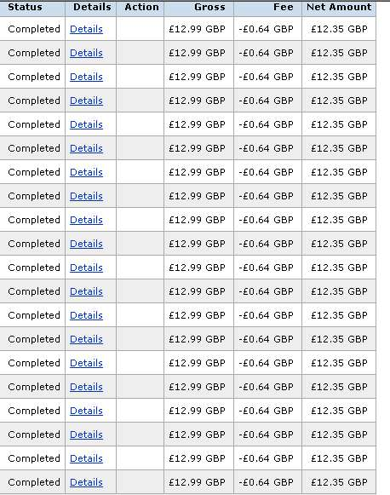

The payments above arrived in the first half hour. 30 minutes!

Selling a package you’ve bought at $10 for $1 will get you a lot of names. It’s well worth the outlay to offer the kind of quality that will have people happy to opt onto your list

So will giving away a free ebook package that directs them to opt in to get MORE on your website.

But how do I set up an opt-in website?

Chapter Seven: Setting up an Opt-in Website

Opt-in websites are web sites or single pages that ask the visitor if they would like to sign up to a mailing list, usually in return for a free product or offer. Because the visitor has to ‘opt’ to join the list rather than automatically being added, the end result is called an opt-in list.

Most people really don’t mind being part of a mailing list. Especially if they’re getting something of real value either for joining, or in the form of ongoing special offers after they’ve joined.

So how do you put together an opt-in page with free offer so you can collect email addresses?

Opt-in sites go from the simple and effective to the bells ringing, lights flashing ridiculously complex.

This is how I do it. Below is a screenshot for the US version of ‘The Bargain Hunter’s Course’. You’ll see that at the very top of the page I offer the free digital camera book (feel free to download it) and a clickable link to the opt-in page

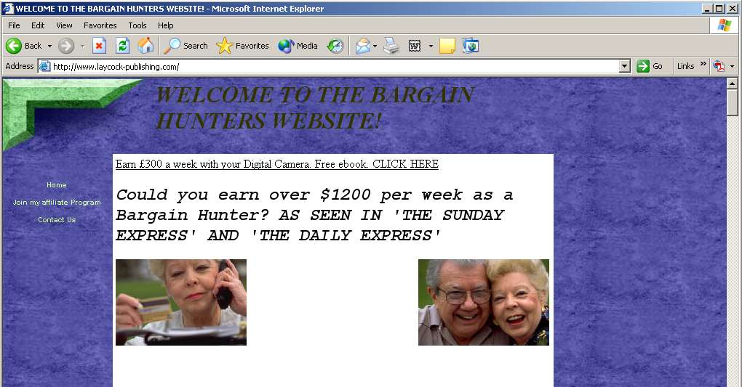

Once they click on the link to get the free book they’re taken to a page that explains what the book contains and how it’s great value for a freebie (which it is). Below that at the bottom of the page is a simple opt-in option.

This is it:

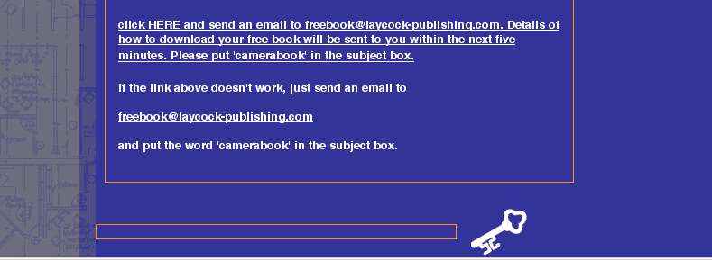

That’s it. It’s clumsy and awkward. Compare it something like this:

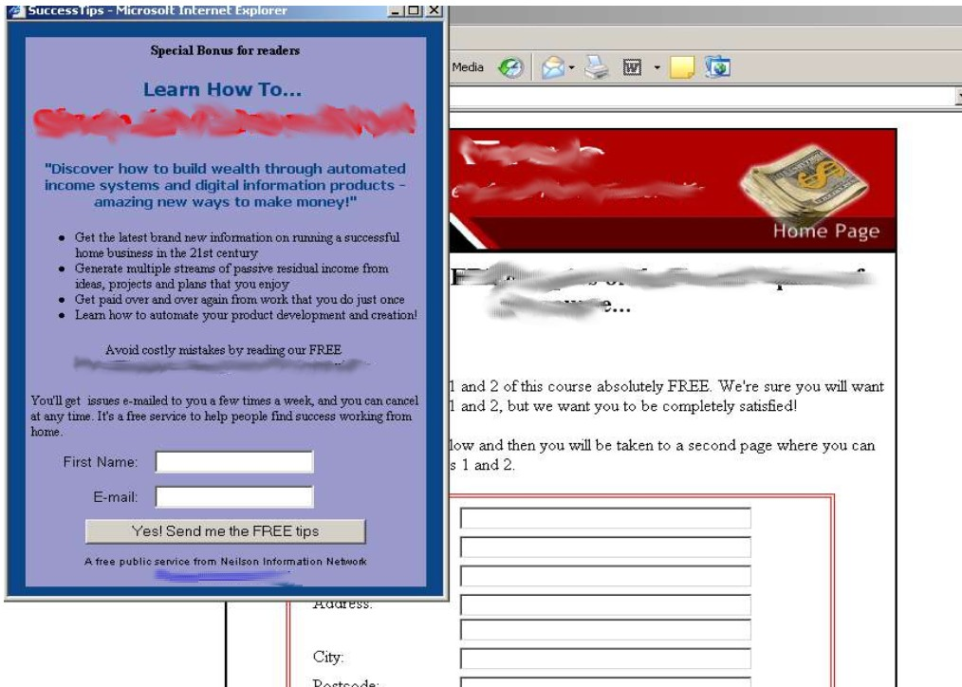

The website above offered me no less than TWO options to add my email address to their mailing list. The main page (in white appeared) then the blue pop-up box slid in quietly from the side!

This is much more professional than my site, and I have a great deal of respect for the owner of this site – he offers a fantastic product and his is one of the few mailing lists I subscribe to because of the excellent content.

BUT it’s not an approach that works for me. I deliberately keep my opt-in page simple and with almost a ‘home made’ feel. I do this (after a lot of market research) because people then don’t feel like they’re signing up to a big mailing list! One customer said

‘I felt like I was emailing a mate for a book I wanted’

Both approaches are fine. Mine works for me.

So how do I know that they’ll enter the correct email address and not someone else’s just to get the book?

It’s easy – set up an auto responder that sends an email with download instructions automatically to the email address they entered. If they enter a false email address they don’t get the book.

This is the email you’ll receive if you send for my free ebook:

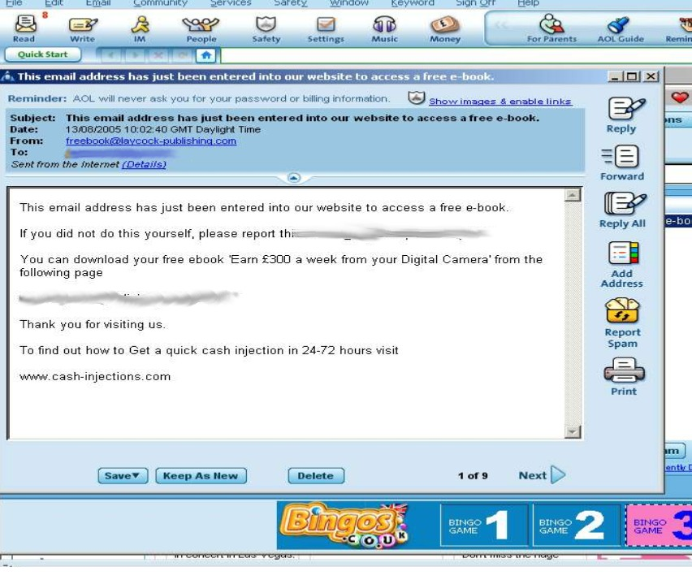

It tells the email address owner that his/her email has been used to try to obtain a free ebook. It gives them an address to report this to if it’s a false one. If it’s a genuine email it tells the new subscriber (now I can add their address to my list) where to download the free book.

I also get manage to pop a free ad on the bottom!

You can get a free auto responder from http://www.getresponse.com/orderfree.html or from doing a Google search for ‘free auto responder’.

Again you don’t have to have a webpage they can download the free book from, you could use the free ebook share service I have mentioned in this book or you could just email them the free book as an attachment.

Using free giveaways is the best way of building your list in my opinion, but use every chance you get to boost your mailing list.

You could put a link at the bottom of all your emails such as:

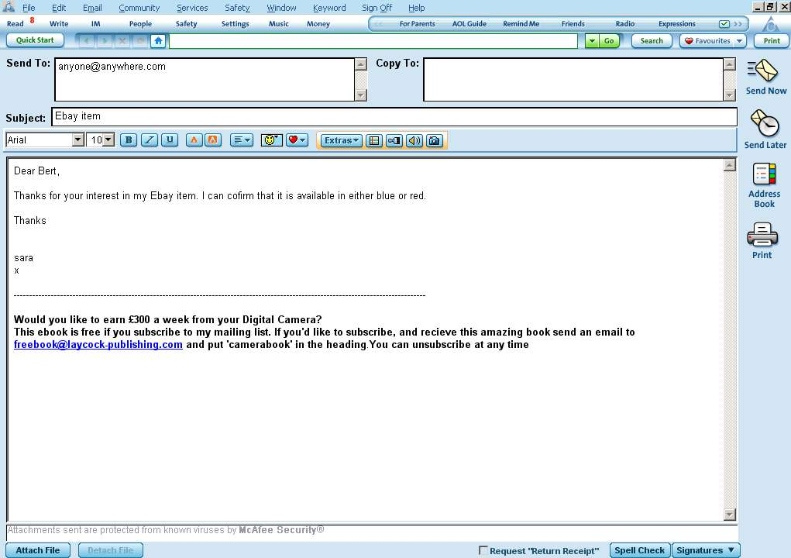

If you put this attachment on every valid email you send, it’s not classed as spam and you’d be surprised at how many people will join your list.

There are other subjects I’d like to cover:

Chapter Eight: Buying a List

Some people buy email lists.

I’ve never done this but it’s possibly a short-term solution for you. If it interests you, have a look at the following site to start with:

http://www.morebusiness.com/running_your_business/marketing/d917647870.brc

Sending out Emails in Bulk

This can be a problem. I have my own hosting provider and they whinge about the sending of bulk emails (I’m talking over a few hundred only!).

When I first started I sent them through my own email account at AOL. Halfway through the mailing AOL shut down my account and only re-instated it only after a lot of hassle! Even then it didn’t work properly for a month.

My own hosting provider is better, but I still have to be wary about how many emails I send out in a 24-hour period. For a long time I couldn’t find a way around this but I’ve recently signed up with a company that has completely solved all my JV and mailing list problems.

I can do unlimited mailings, automatically follow-up emails at periods that I allocate, ( further emails result in better sales), can put opt-in list forms on my website that are automatically added to my list and customise my emails so they address the customer by name.

It costs me $19 a month, and if you’re interested you can test-drive the system (to see if you like it) through this link

http://www.aweber.com/?218514

The biggest blunder I made with my first mailing years ago still makes me cringe. I wrote my email then put all the email addresses into the ‘To’ field of the email. I didn’t realise that meant that every single person I mailed to could see the whole of mailing list. Of course a number of people abused this and re-mailed my list. I got accused of selling names and spamming and it took a long time to sort it all out.

Put your own email address into the ‘To’ field. This means that you’re not giving out anyone else’s address and it has the added benefit of actually checking that the email is being sent.

Put all the other email addresses (i.e. your list) into the ‘BCC or Blind Carbon Copy’ field. This means that the people receiving the email can’t see who you’ve sent it to. Simple but it caught me out!
Conclusion

So that’s it. I’ve introduced you to one of the most lucrative undertakings in the whole of Internet Marketing.

If you’ve never come across this methods before you must try it. If you have come across this method before but not tried it you must try it.

It will change the way you think about money – I guarantee it.

Why? Because undertaking a JV mailing opens the window just on Internet Marketing just a tiny crack. But it’s enough to show you in breathtaking style just how much money is out there to be made.

Doing a little preparation work and pressing a ‘send’ button can bring in thousands of Dollars in a matter of hours.

More importantly it destroys in seconds all the rubbish we’re spoon-fed from birth about having to work hard for money. Instead it teaches us we can work smart.

There are people in the Internet Marketing world who don’t do anything else. They spend a few months preparing a product. Their whole way or working is geared up to collecting email addresses and building opt-in lists. So when the preparation work is done they launch their product to their list (which might contain 200,000 addresses).

Within 48 hours they have made in excess of a Million Dollars. They don’t bother setting up websites or selling on EBay, they just quietly start work on their latest product and adding more addresses to their lists.

It’s all in the numbers. If I could email one million interested people (without spamming!) with my latest offer today I would be a multi-millionaire by tomorrow morning. By tomorrow morning!

My list contains around 3000 people. I have websites and sell on EBay so I don’t build my list as well as I should. Actually that’s my new year’s resolution for 2008.

Just think of this. If I could build up my list and sell my product for just $16.99 to 15,000 people (only 5 times the size of my list – I could have a list this size in a matter of months) - I would make over a quarter of a million Dollars in a couple of days.

If you concentrate solely on mailing list JV’s with either good eBay sellers with a good list or good eBay sellers with a good product you could make a lot of money. One JV per month (taking just 2 days) could easily bring you £1000 a month from a small list. If you built your list steadily day by day and at the same time worked with more and more sellers you could easily bring in $5000, which would increase every month as your list grows. Then there are the foreign eBay sites. UK/USA JV’s are extremely lucrative. A product that sells well in the USA might be unheard of in the UK. Offer it to your list and watch what happens!

This is THE business I wish I’d tried years ago. I might be working from a Georgian mansion rather than a (admittedly very nice) Yorkshire cottage.

I can’t urge you enough to not just put this book down. TRY IT – you’ll be amazed at the results.

Just think again about your job. How long would it take you to earn a thousand Dollars on top of your current salary?

A big bonus?

A lot of overtime?

Or some well-invested time, working from home, in 24 – 72 hours?

Start building your list now.

It’s another weapon in your arsenal against the JOB trap. It’s easier to work for yourself from home than it is to work at a JOB. There are two hard parts to making the leap:

- One of my favourite quotes ‘Never let yourself get into the position where you’re too busy earning a living to make any real money’ – That’s exactly what a JOB does to you.

- Proving to yourself that you actually can make money from home. The first £100 is the hardest, but it proves it can be done. Hopefully this book will sort out this second problem for you.

The first is up to you.

Good luck.

Your Name

www.yoursite.com

